

Hi {{user.first_name}},
Your job as a leader and team coach is to ensure the team knows how to win and if it’s winning week to week.
It’s especially critical when markets and resources are challenging — when the team knows the most important outcomes, everyone can prioritize and contribute to them.
Help your team win more this quarter. With AI-powered suggestions from WorkBoard’s Co-Author, the team can quickly ideate, define and align on objectives and clarify its most important results.

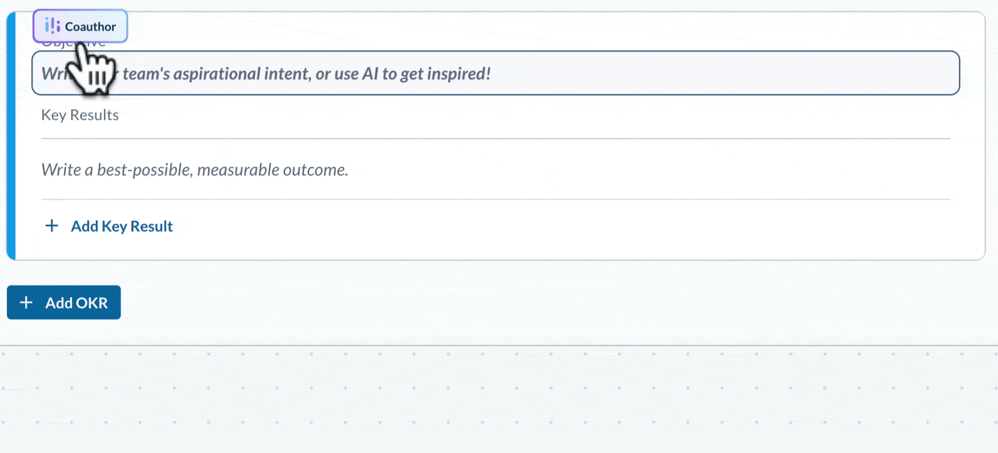

It’s easy to get started. Create a collaborative canvas for your team and ask Co-Author for inspiration on your first objective! Add ideas for team discussion as stickies — then invite the team to contribute their own. (These 3 easy steps can help make your first brainstorming session fast, fun and fruitful!)

Get Started Now!

© 2023 WorkBoard Inc. All Rights Reserved.
Workboard Inc., 487 Seaport Court, Redwood City, CA, 94063
Privacy Policy | {{url.unsubscribe}}

